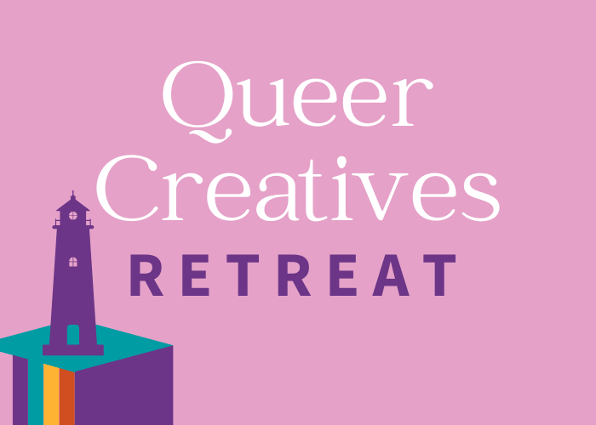

Lighthouse Writers Workshop

Queer Creatives Retreat
October 14-16, 2022

Friday, October 14

9:00am-12:00pm: Morning Intensives

The Queer Possibility in Writing for ages 21+ with Helen Armstrong (Zoom)

2:00pm-4:00pm: Afternoon Craft Seminar

(Re)Claiming Queer/Trans Bodies with Jesaka Long (Zoom)

4:30-5:30pm: Happy Hour/Open Mic
Light refreshments will be provided
Sign up

6:00-7:00pm: Keynote Address with Ashley Cornelius (Hybrid)

In-person sign-up | Zoom sign-up

Saturday, October 15

9:00am-12:00pm: Morning Intensives

The Queer Possibility in Writing for ages 21+ with Helen Armstrong (Zoom)

Life and Death—Predicting Futures in Micro and Flash Fiction with Joseph Ponce (Denver)

12:00pm-2:00pm: Lunch

2:00pm-4:00pm: Afternoon Craft Seminars

Metaphor Magic—An Extended Metaphor Workshop with Ashley Cornelius (Zoom)

Writing Queer Time with Sasha Geffen (Denver)

4:30pm-5:30pm: Free Event

Spellwriting for All Ages with Assétou Xango (Denver)

5:30-6:15pm: Community Dinner
Sign up

6:15pm-7:15pm: Youth and Adult Open Mic
Sign up

Sunday, October 16

9:00am-12:00pm: Morning Intensives

The Queer Possibility in Writing for ages 21+ with Helen Armstrong (Zoom)

Life and Death—Predicting Futures in Micro and Flash Fiction with Joseph Ponce (Denver)

12:00pm-1:00pm: Book Launch Brunch

The Queerest Touch book launch with Brian Byrdsong in conversation with Nancy Viera (Denver)

1:00pm-2:00pm: Closing Party
Sign up

